Your Name |  |  | Lauren Mazzoli
Step / Points |  |  | Paste in your answers for each step below in this column. Paste a screen shot of your Result Grid. Paste your actual SQL text, not a screen shot of it. Be sure to “Snip” your screen shots as instructed in Assignment 02. Please don’t change these cells from double spaced.
1.1 | 3 | Result Grid | 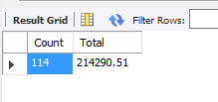
1.1 | 3 | SQL | SELECT  COUNT(*) AS Count, SUM(invoice_total) AS Total  FROM  invoices
1.2 | 3 | Result Grid | 
1.2 | 3 | SQL | SELECT  AVG(invoice_total) AS Average,  MIN(invoice_total) AS Minimum,  MAX(invoice_total) AS Maximum,  COUNT(*) AS Count,  FORMAT(SUM(invoice_total), 2) AS Total  FROM  invoices  WHERE  invoice_date < '2015-07-01'
1.3 | 3 | Result Grid | 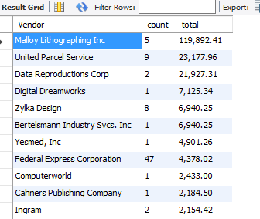
1.3 | 3 | SQL | SELECT  vendor_name AS Vendor,  COUNT(*) AS count,  FORMAT(SUM(invoice_total), 2) AS total  FROM  invoices  JOIN  vendors ON invoices.vendor_id = vendors.vendor_id  GROUP BY vendor_name  ORDER BY SUM(invoice_total) DESC
1.4 | 6 | Result Grid | 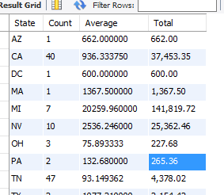
1.4 | 6 | SQL | SELECT  vendor_state AS State,  COUNT(*) AS Count,  AVG(invoice_total) AS Average,  FORMAT(SUM(invoice_total), 2) AS Total  FROM  invoices  JOIN  vendors ON invoices.vendor_id = vendors.vendor_id  GROUP BY State
2.1 | 6 | Explain Why Subquery | A subquery is a query within a query. When a subquery is executed, it creates a temporary subset of results that can be a value, a list, or another table. This results set is then used as a variable that is applied to some part of the main select statement in order to create the final results-set that is desired. A subquery is the statement of choice when an aggregate function such as AVG needs to be used as a condition to select an attribute in the same table in the main SELECT statement. It also makes sense to use a subquery, rather than a join, when there is no data from the second table required in the final results set and there is no obvious relationship that can be used that exists between the between two tables to get the data that is needed, such a primary key and a foreign key that links them together and is commonly understood. In the back-end processing, the DBMS performs two very different algorithms for a subquery versus a join; Depending upon the amount of data in the tables in question, performance and data storage differences may need to be considered when discerning whether to use a subquery or a JOIN  In the subquery code example below, a list of vendors who have a default payment term of over net 30 days are displayed sorted by highest payment term and then vendor name. To achieve this result, the subquery statement generates a list of payment term id’s that are over net 30 days. The main select statement then queries the vendor table to compare each vendor’s default_term to the list of term_ids generated by the subquery and selects only those rows where the default payment term is in the list for the final results set. Note that regardless of which method is used to generate the result set, the code is dependent upon the standards the business has put in place to enter a payment term description and the resulting integrity of the data in this column. Because the payment terms description is not an established relationship, the data in this column could change and therefore produce an outcome that does not meet the specification as sgated above. This is a risk inherent to using SQL queries developed by users. The SQL developer should take this into consideration and understand the system’s data validation process and the length of time that this query will need to be used before determining if it is a good solution.
2.1 | 6 | Explain Why Join | A Join clause is appropriate when you need to include data from more than one table in the results-set. If this is not the case and you do not have to use a subquery to acquire an aggregate result to be used in a condition in the main SELECT statement, you can choose whether to use a JOIN or a subquery to meet your requirements; A JOIN is preferred when the code will produce a more straightforward solution. Assuming that this query will be used again, using a JOIN that is easier to understand will mitigate the risk of a future logic error during the maintenance phase of the SDLC. Therefore, if the tables needed to satisfy the query requirements have an obvious one-to-many relationship that can be leveraged, a JOIN is the preferred choice. The code example below is not difficult to understand in either scenario. This query is not something that would be done often. It can go either way (a JOIN or subquery) because it is more of an ad-hoc query that could be used by managers to determine the companies that would be affected if future payment terms were set to a different time period. However, in my judgement, the join would be slightly easier to understand because it is more prevalent, according to the best business practices as outlined in Chapter 7 of Murach’s MySQL 2nd Edition.
2.1 | 6 | Subquery Result Grid | 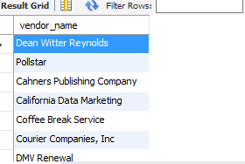
 |  | Subquery SQL | SELECT  vendor_name  FROM  vendors  WHERE  default_terms_id IN (SELECT  terms_id  FROM  terms  WHERE  terms_description > 'Net due 30 days')  ORDER BY default_terms_id DESC , vendor_name
 |  | Join Result Grid | 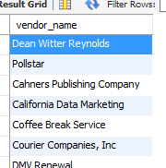
 |  | Join SQL | SELECT  vendor_name  FROM  vendors  JOIN  terms ON default_terms_id = terms_id  WHERE  terms_description > 'Net due 30 days'  ORDER BY default_terms_id DESC , vendor_name
2.2 | 3 | Result Grid | 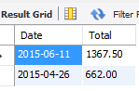
2.2 | 3 | SQL | SELECT  invoice_date AS Date, invoice_total AS Total  FROM  invoices  WHERE  vendor_id IN (SELECT  vendor_id  FROM  vendors  WHERE  (vendor_state = 'MA'  OR vendor_state = 'AZ'))  ORDER BY invoice_date DESC
2.3 | 6 | Result Grid | 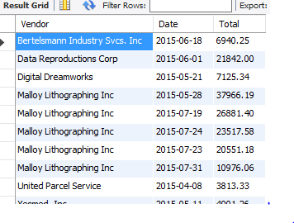
2.3 | 6 | SQL | SELECT  vendor_name AS Vendor,  invoice_date AS Date,  invoice_total AS Total  FROM  invoices  JOIN  vendors ON invoices.vendor_id = vendors.vendor_id  WHERE  invoice_total > (2 *  (  SELECT  AVG(invoice_total)  FROM invoices  )  )  ORDER BY  vendor_name,  invoice_total DESC
 | 30 |  | Total Points

